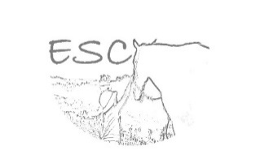
SCHOOL HOLIDAY REGISTRATION

Thank you for your interest in ESC’s Holiday Program. Please complete the following.

Child’s Name:_________________________ Parent’s Name:_______________________

Member of Pony Club Australia? ___________________
Would you like more information on becoming a member of Pony Club?_________________

Are you interested in the:
Full Day (9am-3pm @ $120 each child) or Mini Day (9am – 12pm @ $60 each child)

Experience with horses: __________________________________________________________________________________________________________________________________________________________________________________________________________________________________________________________________________________________________________________________________________________________________________________________________________________________________________
Please provide your preference for days:
Monday 13th April
Tuesday 14th April
Thursday 16th April
Tuesday 21st April
Wednesday 22nd April
Thursday 23rd April

We will be in touch shortly to confirm your child’s place.

Enquiries to:
escoaching21@gmail.com / 0433 211 028

